Venus Notes
Drawing: (color)
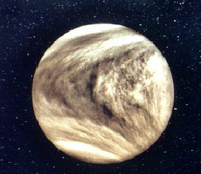

- Venus has phases like our Moon.
- Venus is always seen near the Sun as a "morning star" or "evening star". (along with Mercury) ** TEST**
- Semi-major axis: 0.72 AUs
- Orbital period : 225 days
- Temperature: 755K – hottest planet **TEST**
- Earth’s sister planet—because of its size and composition **TEST**
  - Diameter: 9/10ths of the earth
  - Density is 5.25
- Axis tilt = 178ᵒ --- Venus is upside down --- north pole is pointing down.
- No Moons
- Mass: 4/5th of the earth
- Retrograde Motion: Venus is the only planet that rotates "backwards". (243 days for one rotation)
- Has a sulfuric acid clouds **TEST**
- Venus is named after god of beauty and love---- form a distance she is gorgeous, close up she is a beast.
Music Journal:
Write paragraph on what Venus’s music will sound like a why.
After listening—what does Venus’s music sound like and why?
4/8/14 --- Venus continued
layers of venus:
Similar to the earth- iron nickel core, rocky mantle, crust.
- The surface is completely hidden beneath a permanent cloud cover.

Atmospheric composition:
Carbon dioxide: 97%
Nitrogen: 3%
Atmospheric pressure = 90x atmosphere of Earth
Total amount of CO₂ is about the same on Venus as it is on Earth
probes: Mariner 2, 5, 10 and Magellan

Terrain on Venus:
Ishtar Terra
Aphrodite Terra
Mona Lisa Crater
Mead Crater—largest Crater on Venus
80% of venus is flat

Hottest planet due to green house gases
Runaway greenhouse effect—traps heat and warms up—heat comes from sun.

No plate tectonics
No magnetic field

