Unit 1 Study guide:
Metric to Metric conversions
K H D b d c m
Move decimal space to convert from one metric unit to another.
8 m = ____800______ cm
4,000 cm = ____.04_____ km

Dimensional analysis
Use to convert from metrics to non-metrics and vice versa.
Example:
12 inches = 1 foot; 1 inch = 2.54 cm
Convert 6 ft to cm
6 ft 12 in 2.54 cm = 6ft is equal to 182.88 cm
1 ft 1 in
Scientific Notation
A way of writing really big numbers or really small numbers.
Be able to write a standard number in scientific notation and a scientific notation number in standard form.
Example:
8,000,000,000 is also 8.0x10⁹
0.000000008 is also 8.0x10⁻⁹
Significant Figures
Using the Pacific- Atlantic rule, we can decipher how many significant figures there are in the number.
Pacific Ocean Atlantic Ocean
Present Absent

Example: In the number 0.0000823; the decimal is present, begin from the “pacific” side (left) of the number and don’t start counting until you reach a non-zero, then count all the numbers remaining. 0.0000823 has 3 significant figures.
Example: In the number 82300000; the decimal is absent. Begin from the “atlantic” side (right) of the number and don’t start counting until you reach a non-zero number, then count all the numbers remaining. 82300000 has 3 significant figures.
When multiplying 2 numbers together, the final answer in your calculation can only be as precise as the lowest amount of sig figs in your original numbers. For example, if I multiply 3.1m X 1.7253m, my calculator says 5.34843, however, the appropriate answer would be 5.3m² because of the 3.1 in the original calculation.
Measurements
In physics, we use SI units (metric units). To measure length, we use kilometers, meters, or centimeters. Kilometers are very large. Centimeters are very small.
We measure time using seconds.
We measure mass using kilograms.
Graphing
Be able to interpret the data on a graph.
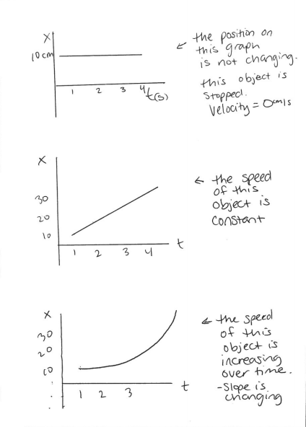
The graphs above are position- time graphs. The slope of the graphs above tell us the velocity of the object in motion.
To find the slope of a linear graph (choose 2 points on the line):
y₂ – y₁
x₂- x₁

