Series Circuit Practice
Fill in the chart below using the infromation from the series circuit:
Don’t forget the rules of Series circuits:
Resistance: Add up all the resistors. R_{T} = R₁ + R₂ + R₃…
Current: Current stays the same at each resistor I_{T} = I₁ = I₂ = I₃…
Voltage: Add up to get total voltage ΔV_{T} =ΔV₁+ ΔV₂ + ΔV₃…
Ohm’s Law is V=IR
Practice problem 1:
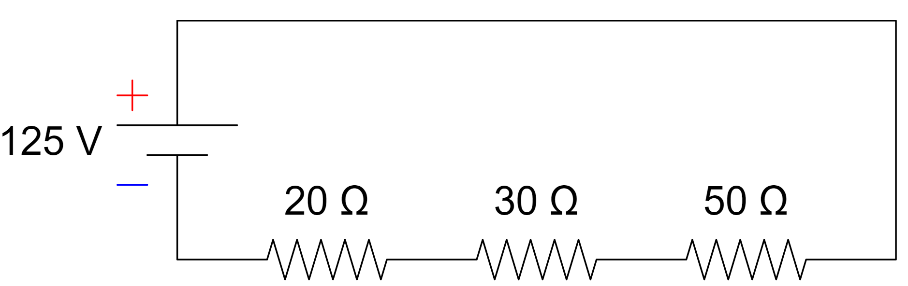
R_{T}= | I_{T}= | V_{T}=
R₁= | I₁= | V₁=
R₂= | I₂= | V₂=
R₃= | I₃= | V₃=

Practice problem 2:
20
18
12
110
R_{T}= | I_{T}= | V_{T}=
R₁= | I₁= | V₁=
R₂= | I₂= | V₂=
R₃= | I₃= | V₃=
Questions on Series Circuits: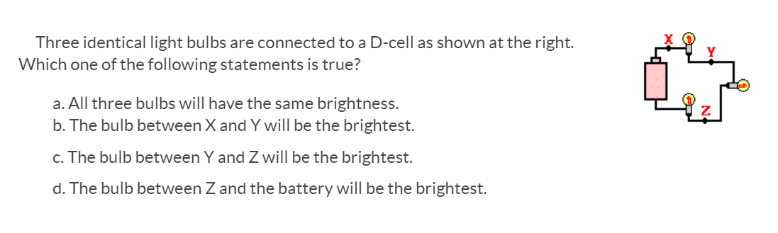
3.
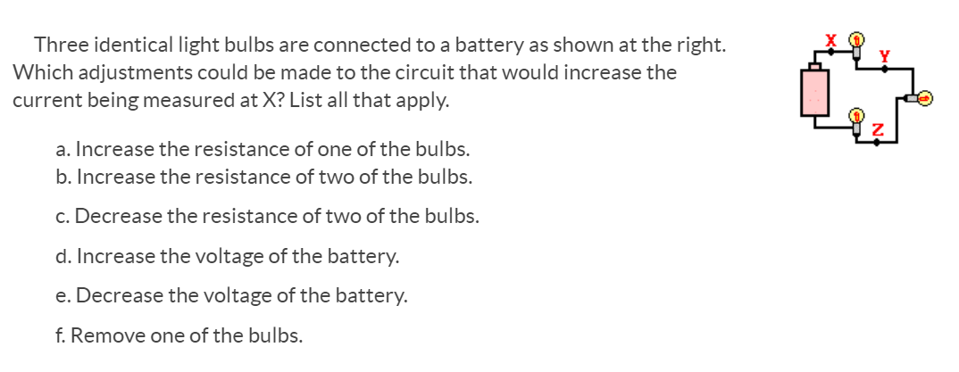
4.
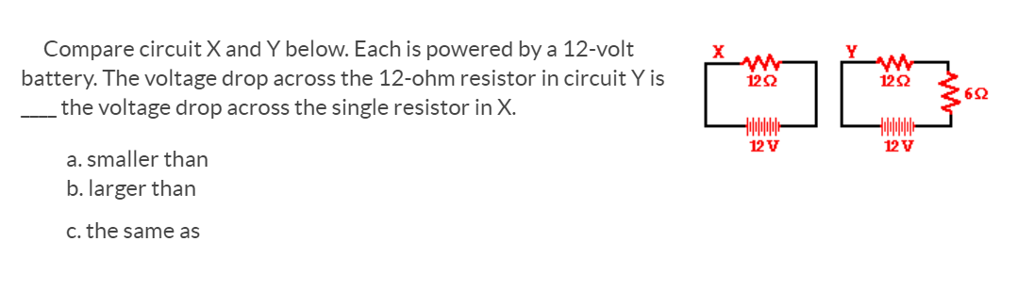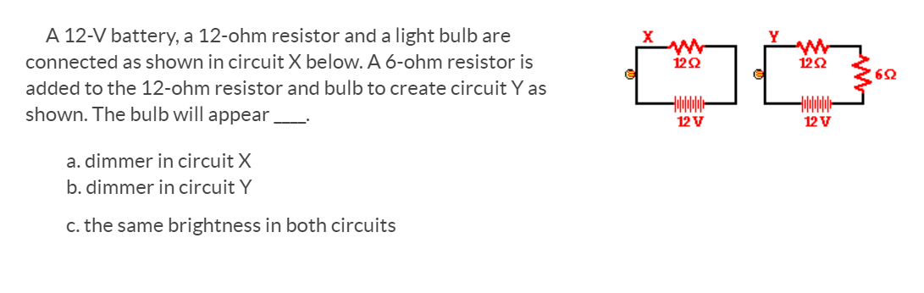
5.
6.

