When I was a kid, my uncle used to make potato launchers out of PVC pipes and a lot of WD 40. We would shoot potatoes across the lake and try to get it to reach the other side.
Using the diagram at the bottom of the page, answer the following questions:

1. What are the horizontal and vertical velocities of the potato (v_{x} and V_{iy})?

2. How long does it take the potato to reach its maximum height (half time)?

3. What is the maximum height of the potato (d_{y})?

4. How long does it take the potato to reach the other side of the lake (full time)?

5. What is the total horizontal distance the potato traveled (d_{x})?

6. What is the velocity of the potato when it is at its maximum height (v_{y} at peak)?

7. What is the total velocity of the potato when it reaches the other side of the lake?
58 m/s
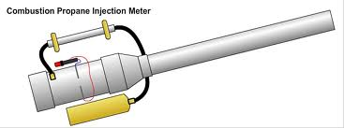
40ᴼ

