Parallel Circuit Practice
Fill in the chart below using the infromation from the parallel circuit:
Don’t forget the rules of parallel circuits:
1- Resistance: 1/R_{T} = 1/R₁ + 1/R₂ + 1/R₃…
2- Current: I_{T} = I₁ + I₂ + I₃…
3- Voltage: ΔV_{T}= ΔV₁ =ΔV₂ =ΔV₃
4- Ohms Law: V= IR
Practice problem 1:
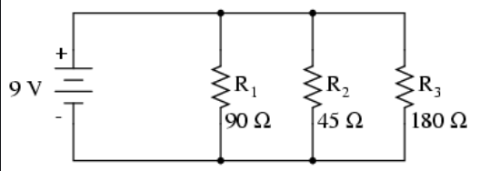
R_{T}= | I_{T}= | V_{T}=
R₁= | I₁= | V₁=
R₂= | I₂= | V₂=
R₃= | I₃= | V₃=

Practice problem 2:
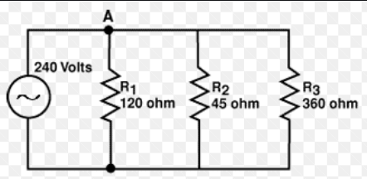
R_{T}= | I_{T}= | V_{T}=
R₁= | I₁= | V₁=
R₂= | I₂= | V₂=
R₃= | I₃= | V₃=

Questions on Parallel Circuits:
3. As more and more resistors are added in parallel to a circuit, the equivalent resistance of the circuit ____________ (increases, decreases) and the total current of the circuit ____________ (increases, decreases).

4. Three identical light bulbs are connected to a D-cell as shown below. P, Q, X, Y and Z represent locations along the circuit. Which one of the following statements is true?
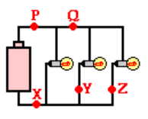
a. The current at Y is greater than the current at Q.
b. The current at Y is greater than the current at P.
c. The current at Y is greater than the current at Z.
d. The current at P is greater than the current at Q.
e. The current at Q is greater than the current at P.
f. The current is the same at all locations.

5. Which adjustments could be made to the circuit below that would decrease the current in the cell? List all that apply.
a. Increase the resistance of bulb X.
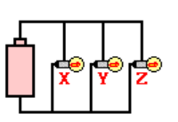
b. Decrease the resistance of bulb X.
c. Increase the resistance of bulb Z.
d. Decrease the resistance of bulb Z.
e. Increase the voltage of the cell (somehow).
f. Decrease the voltage of the cell (somehow).
g. Remove bulb Y.

