Notes on Forces
Dynamics- something moving
Statics- not moving
A force is a vector quantity (magnitude and direction).
Forces are measured in Newtons (A newton is made up of a mass and an acceleration).
Forces at a distance- field forces – gravity, static electricity, etc.
Newton’s 3 laws
- Law of Inertia- an object at rest tends to stay at rest and an object in motion tends to stay in motion, unless operated on by a net external force.
- Force = mass X acceleration (F=ma)
- For every action, there’s an equal and opposite reaction.
Free Body Diagrams
A picture of a situation with all the forces labeled on the diagram.
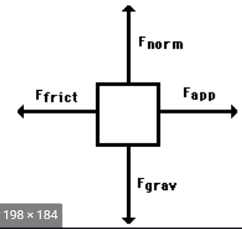

Friction- a force operating opposite of the motion of the object.

