Magnetism Mini Lab
Go to the following website
http://phet.colorado.edu/simulations/sims.php?sim=Magnets_and_Electromagnets
Click
Move the compass around the bar magnet.
- Which pole of the magnet does the red compass needle point towards?
Click “Flip Polarity” in the right menu.
- Now which pole of the magnet does the red needle point towards? Does it still point toward the same pole?

- This means that the red part of the needle is a _________ pole.
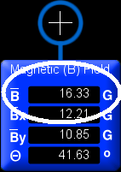
Click in the right menu.
Check the box “Show Field Meter” in the right menu. A blue box should appear. This measures the Magnetic Field around the magnet (which is known as ‘B’). The Magnetic field is measured in Gauss (G). Move the field meter around the magnet.
- Does the field increase or decrease as you move the meter closer to the magnet?
Move your meter so that it is about one inch (on your computer screen) away from the North end of your magnet.
- What is the magnitude of field strength (B) in Gauss?
Now move the meter the same distance away from the South end of your magnet.
Is the amount of magnetic field the same for both North and South ends of a magnet?

