Jupiter Notes 3/31/15
Jupiter is LARGE!
2 ½ times larger than all of the other planets combined.
If it were 80 times larger it would be a star
1000 times larger than Earth.
Jupiter is 11 earths across
The diameter is 11x Earth’s diameter.
Atmosphere:
90% Hydrogen
10% Helium
- Huge gravity holds the light elements from escaping
- Hydrogen exists in all three of its states (solid, liquid, and gas)
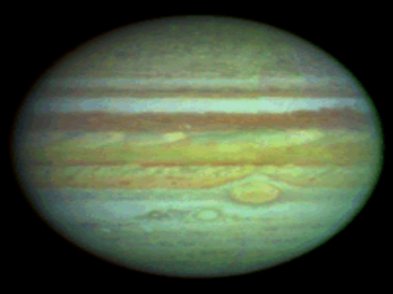

Density:
1.3 g/cm³
Distance:
5 A.U.s away from the sun

Surface Features:
**TEST**BELTS AND ZONES:
Belts are reddish colored
Zones are light-colored

Drawing: colored.
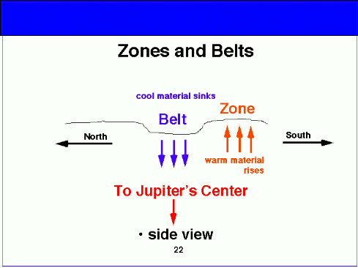

Composition of Jupiter:

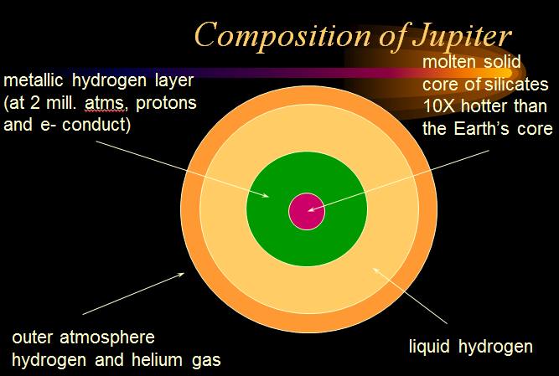

9.8 hours for one rotation of Jupiter (really really quick)
11.94 years – 1 revolution
Has a HUGE magnetic field
Temperature:
125K

Jupiter’s Heat:
Not the greenhouse effect
More energy is leaving Jupiter than arrives
Jupiter has an internal heat source

Jupiters magnetosphere:
Extends over 5 AUs
20,000 times stronger than Earth’s magnetic field
Jupiter is named after the god Zeus
Jupiter’s moons are named after people Jupiter arm wrestled with.

Jupiter has rings:
very small particles.
...The rings are smaller than Saturn’s
…...because Jupiter is closer to the Sun and most particles have shrunk or melted.
THIN ICE RING

Probes:
Pioneer 10
Pioneer 11
Voyager 1
Voyager 2
Juno
Galileo

Satellites:
Jupiter has 16 main moons, 50 small moons
4 you need to know:
  - Io, Europa, Ganymede and Callisto
  - Io- (pizza moon) It is the hottest moon in our solar system.
    - Smelliest moon because of the sulfur volcanoes
    - Still geologically active.
  - Draw: 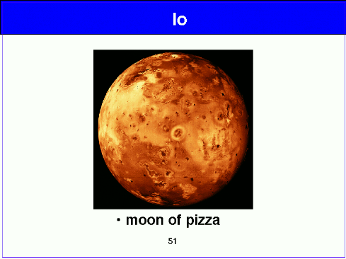
  - Europa:
    - few craters
    - frozen Water Ice
      - possible water ocean under the ice
    - Draw: 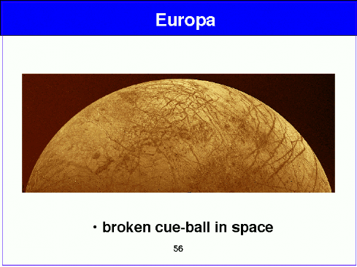
  - Ganymede: -- largest moon in the solar system
    - Similar structure to Earth’s moon
    - Water on Ganymede replaces lava on moon
    - Frozen maria covers much of the landscape
    - Draw: 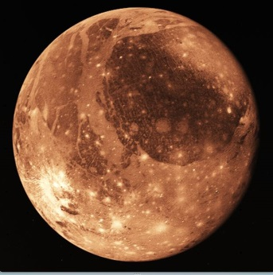
  - Callisto : Farthest of the Galilean moons from Jupiter
    - Similar to Ganymede
    - More craters and fewer faults
    - Valhalla impact basin
    - Draw:

