Final Review Name:_____________________________________________
Unit 6 - Momentum and Impulse
- What is the formula for momentum?

- What is the formula for impulse?

- A 1000 kg car is moving at 20 m/s. The momentum of the car is:

- A ball was hit by a bat. The impact force is 250 N, and the contact time is 0.2 s. What is the impulse received by the ball?

- A car crashed into a wall. The impulse is 4000 N-s and the impact time is 0.5 s. What is the impact force on the car?

- The momentum of a car is 35,000 kgm/s. The mass of the car is 1500 kg. What is the velocity of the car?

- A 1000 kg car crashed into a garden and stopped. The impulse is 4000 Ns and the impact force is 2000 N.How long it takes for the car to stop?

- A 2 kg model airplane travels with a velocity of 10 m/s north. A tail wind (blowing from behind) applies a force of 1 N to the north for 2 seconds. What is the final velocity of the airplane?

- In an inelastic collision, a 900 kg car is at rest at a traffic light when a 760 kg car traveling at 10m/s crashes into its rear. Assuming that no breaks are used, what is the velocity of the cars after the collision?

UNIT 7- WAVES

- A wave has a velocity of 7.4 m/s and a frequency of 34 Hz. What is the wavelength of the wave?

- A transverse wave is traveling with a wavelength of .04 m and at a frequency of 12 Hz. What is the speed of the wave?

- A wave is traveling at 8 m/s and is .025 m from crest to crest. How many cycles per second is the wave traveling?

- Bananas are placed on a spring scale to weigh them. The mass of the bananas is .37 kg. The spring has a spring constant of 415 N/m. What is the distance that the spring stretched?

- An ambulance is coming closer to the observer. If the ambulance is going 34 m/s and the frequency of the siren is 450 Hz, what is the frequency that is observed by the person? (Speed of sound is 340 m/s)

- Label the wave
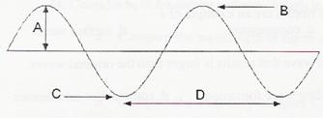
- How are frequency and period related in simple harmonic motion?

- A longitudinal wave has energy that is parallel or perpendicular to the wave?

- How many nodes does a 207th harmonic standing wave have?

- T or F: Hooke’s Law states that the force exerted by a spring is directly proportional to the amount it is stretched

- T or F: The unit for period is Hertz, or cycles per second.

UNIT 8- Light

- Fill in the chart:
King |  | Died | by |  | chocolate | milk
 | Hecto |  |  | deci

- Convert 4 km to millimeters

- Convert 3.8 gigahertz to nanohertz. Put your answer in scientific notation.

- Fill in the EM wave Spectrum: 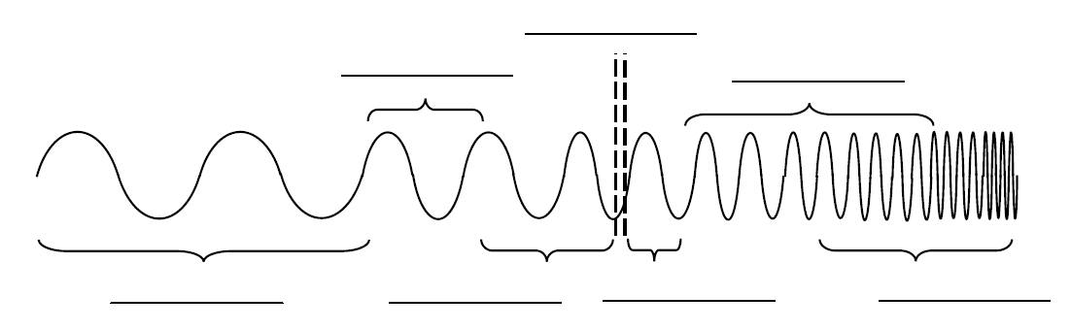

- An electromagnetic wave has a wavelength of 2,000 nm. What is the frequency of this wave?

- The primary colors are ________________, ___________________ and ___________________

- The secondary colors are ____________________, ____________________, and _________________

- Find the angle of refraction for a ray of light that enters a bucket of water from air at an angle of 25º to
the normal. Index of refraction of air = 1 Index of refraction of water = 1.333

- Which color is produced by mixing green light and blue light?

- Which wave from the electromagnetic spectrum has the longest wavelength?

- An object located 30 cm in front of a lens forms an image on a screen 10 cm behind the lens. What is the focal length of the lens?

- Find the height of an image when a 6 cm tall object placed 48 cm from a concave mirror that has a focal length of 18 cm. (Put answer in centimeters and meters).

- For each problem draw a ray diagram and solve for the appropriate variables using the formulas provided.

  - Determine the image distance and image height for a 5.0 cm tall object placed 45 cm from a concave mirror having a focal length of 15cm.

  - Determine the image distance and image height for a 5 cm tall object placed 20 cm from a concave mirror having a focal length of 15 cm.

  - Be able to recognize what kind of images are produced from concave and convex mirrors as well as concave and convex lens.

UNIT 10 – Electricity
- Define electrostatics

- Formula for Coulomb’s law:

- Formula for Ohm’s Law:

- A negative charge of -2.0 x 10⁻⁴ C and a positive charge of 8.0 x 10⁻⁴ C are separated by 0.30m. What is the force between the 2 charges?

- A walkman uses a standard 1.5 V battery. How much resistance is in the circuit if it uses a current of 0.01 A?

