Final Exam Formula Sheet
Momentum and Impulse
p=mv
J=Ft
Ft = m(vf – vi)
Ft = mvf - mvi
m1v1i + m2v2i = m1v1f + m2v2f
m1v1i + m2v2i = (m1 + m2)vf
0 kgm/s = m1v1f + m2v2f
Waves
λ = v/f
v = λf
f= v/λ
f = 1/T
T = 1/f
$$T=2π\sqrt{L}/g$$
F = -kx
PE_{spring}= ½ kx²
L = n/2 λ

Light and Optics
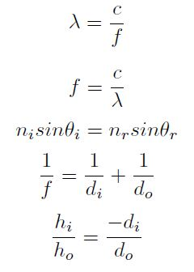
Electricity
F = kq₁q₂/d²
^{V = IR}

