Physics Notes - Hooke’s Law 3/13/15

**The Mass on a Spring**

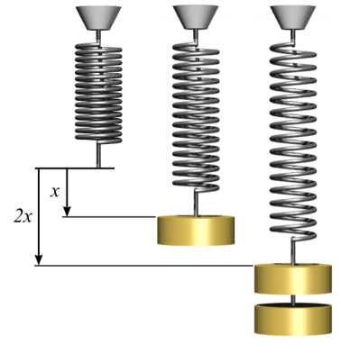

The first spring ____________________________________stretch because nothing is attached to it.



The second spring is ___________________________________since there is __________________________



acting on the spring. The spring is stretched a ______________________________ of _______.



The third spring is stretched even _______________________________ when more__________________ was added.



Let’s look at Hooke’s Law---

Hooke’s law states that __________________________________________________________________________________________



__________________________________________________________________________________________



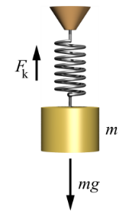The force exerted on a spring is _______________________________ to the ________________________________________________ times the ________________________________



the spring is compressed or stretched from its equilibrium position.



F stands for ____________________________ and is measured in _____________



k stands for ____________________________and is measured in _____________



x stands for ____________________________ and is measured in _____________



**Potential Energy in a Spring**



The potential energy in a spring is equal to _________________________ times the product of the _____________________________________________ and the square of the __________________________



PEspring stands for __________________________________and is measured in _____________



k stands for ____________________________________and is measured in _______________



x stands for ___________________________________ and is measured in ________________



Examples:

1. You are weighing bananas at the grocery store on a spring scale. What is the force exerted on the banana if the spring is stretched a length of 0.5 m and the spring constant is 120 N/m?



Formula:



Plug in numbers:



Solve:



2. If a spring has a constant of 4 N/m and is stretched .5 m, what is the force of the spring?



Formula:



Plug in numbers:



Solve:



3. A spring is stretched .6m when a mass of 4kg is hung on it. Calculate the spring constant of this spring.



Formula:



Plug in numbers:



Solve:



4. A spring is stretched 0.4m from equilibrium. The spring constant of the spring is 2000 N/m. What is the potential energy of the spring?



Formula:



Plug in numbers:



Solve:



5. A compressed spring has 15,000 J of stored energy. If the spring constant is 1,000 N/m, how far is the spring compressed?



Formula:



Plug in numbers:



Solve:

