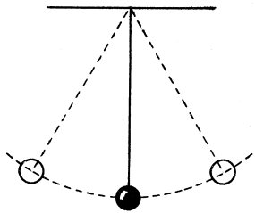
Pendulum Lab Name: __________________________

Goal: Find what changes the period of a pendulum.
To find the frequency:
The definition of frequency is the number of cycles of a wave per second.
Cycles per second
How many times the pendulum goes from one side to the other in one second.
To find the period:
The definition of period is the amount of seconds it takes to complete one cycle.
Seconds per cycles
Time how long it takes for the pendulum to get from starting point to starting point.
Cycle: From starting point to starting point is one cycle. There and back.

Example:
If the pendulum goes 5 cycles in 7.9 seconds, find the frequency and the period.
Frequency:
Cycles 5 cycles = .6329 Hz
sec 7.9 sec
Period:
Sec 7.9 sec = 1.58 s
cycles 5 cycles

Directions:
By changing different factors of a pendulum, find out which one changes the period of a pendulum.
Materials:
You will need to following items:
String
Masses
Tape
Meter stick
Stop watch (on your phone)
Protractor
Procedure:
1. Use the string to create the length of the pendulum.
2. Tie the mass to the pendulum.
3. Find a place in the room to hang your pendulum.
4. Using your protractor, swing your pendulum from an angle less than 90ᵒ
5. Time how long it takes your pendulum to complete one cycle. Record your time in the chart below.
6. Every time you change something about your pendulum, mark down your data in the chart.
Data Charts:
Change the mass of the pendulum:
String length:  Angle dropped: | Mass: | Trail 1: | Trial 2: | Trial 3: | Average:
 | 20 g
 | 50 g
 | 100 g

Change the length of the pendulum:
Mass:  Angle dropped: | String Length: | Trail 1: | Trial 2: | Trial 3: | Average:
Change the angle at which you drop the pendulum:
String length:  Mass: | Angle: | Trail 1: | Trial 2: | Trial 3: | Average:
 | 90˚
 | 65˚
 | 30˚

Conclusion: (Write 3 sentences about what factor above changed the period of your pendulum)

