Friction
Friction is __________________________________________________________________________________________
__________________________________________________________________________________________
2 kinds of friction:
____________________________ Friction: Frictional force that is exerted when an object is
____________________________(not moving).

_________________________________ Friction: A frictional force that is exerted against an applied force
when an object is ___________________________________.
__________: greek letter mu,___________________________________________________________.
Unitless number that indicates how ___________________ or ______________________________ a surface is.
________________________________ : rough (sand paper)
_________________________________: smooth (ice)

F_{f} = ___________________________ measured in __________________
µ = ___________________________ measured in __________________
F_{N} = ___________________________ measured in __________________

Example of Kinetic Friction
A 950kg car has run out of gas and is being pushed with a force of 3,000N. If the coefficient of friction of the road is 0.3, (a) draw a free body diagram and (b) find the acceleration of the car.

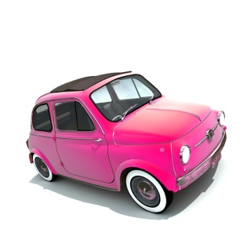

Find the car’s weight:

Find the Frictional Force:

Find the car’s acceleration:

