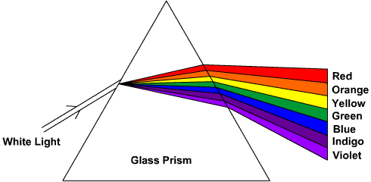
Visible Light 4/17/15

White light is a combination of all colors in the visible light spectrum.
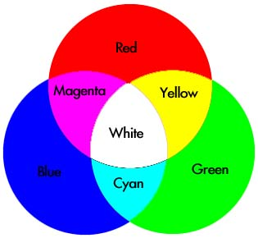

Primary colors: Red, Green, Blue
Secondary Colors: Magenta, Yellow, Cyan
Combining all three primary colors will give you white.

Complementary Colors:
Two colors are complimentary if they form white light when combined.

Examples:
Magenta and green are complimentary.
Blue and yellow are complimentary.
Examples of Reflection:
A piece of white paper under green light would appear to be _______________________________.
Answer: Green.

Mr. Crowder’s cyan colored shirt reflects ___blue and green ____ and absorbs _____red_____.

A piece of paper absorbs magenta, the paper is colored ____________________.
Answer: green

A car absorbs red, green, and blue, so the car appears ______________.
Answer: black

Whatever color is reflected is what you see.
Whatever color is absorbed is the complementary color.

