Trigonometry Review 10/16/14
The Pythagorean Theorem

a² + b² = c²

When dealing with vectors in Physics, we often see right triangles, and this is when we would use Pythagorean Theorem. We use this to solve for the lengths of the different sides of the right triangle.
“a” and “b” are the lengths of the legs of the right triangle and “c” is the length of the hypotenuse of the right triangle.
Solve:
5 m
X
1.) 2.)
2.3 m
X
7 m

14 m

X
3.) 4.)
1.8 m
X
12.2 m
3.7 m

4.6 m

Now that you can find the hypoteneuse of a right triangle, let’s see how we find the length of the sides if we are given an angle of the triangle.
Remember:
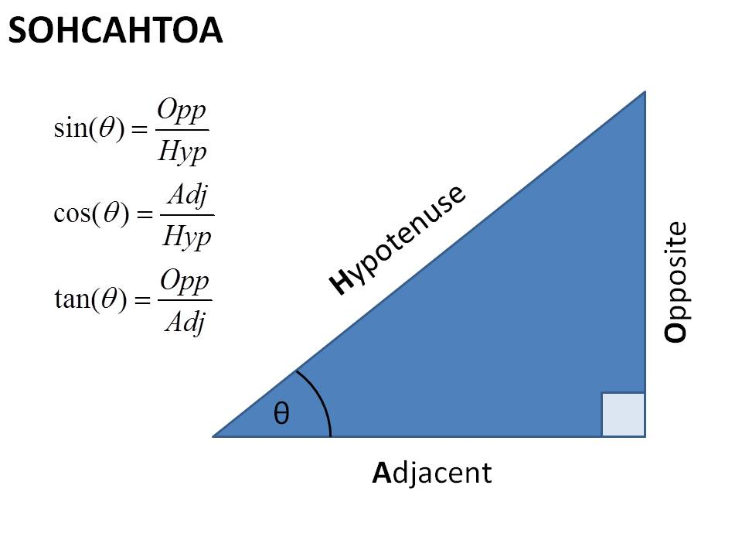
Solve:
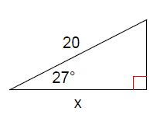
1.) 2.)
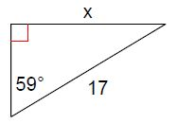

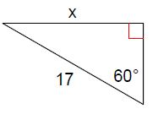
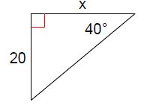
3.) 4.)

We can also use inverse trig functions to solve for the angle if we have 2 sides of the right triangle.
For example: If we are given the length of the hypotenuse and the length of the adjacent side, our triangle would look like this:
14 m

Ө
10.5 m

We can solve for Ө (the angle) by using SOHCAHTOA…. Inverse trig functions.

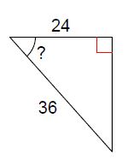
Solve:
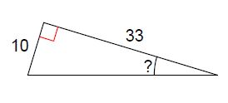
1.) 2.)

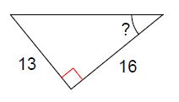
3.)

