Trigonometry Review
The Pythagorean Theorem

When dealing with vectors in Physics, we often see________________________________________________,
and this is when we would use Pythagorean Theorem. We use this to solve for the _______________________
of the different sides of the ____________________________ triangle.
“________” and “____________” are the lengths of the legs of the right triangle and “__________” is the length of the hypotenuse of the right triangle.
Solve:
5 m
X
1.) 2.)
2.3 m
X
7 m

14 m

X
3.) 4.)
1.8 m
X
12.2 m
3.7 m

4.6 m

Now that you can find the hypoteneuse of a right triangle, let’s see how we find the length of the sides if we are given an angle of the triangle.
Remember:
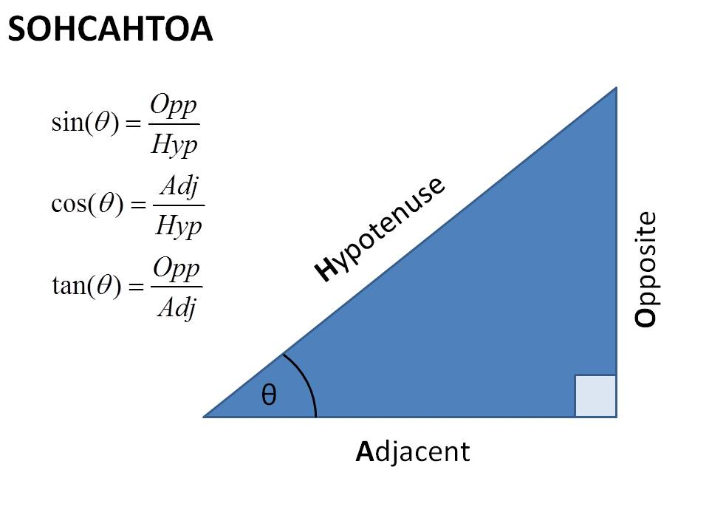
Solve:
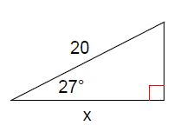
1.) 2.)
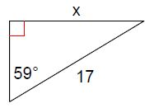

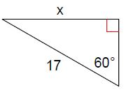
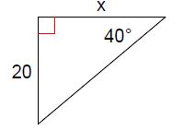
3.) 4.)

We can also use inverse trig functions to solve for the _______________________ if we have 2 sides of the right triangle.
For example: If we are given the length of the hypotenuse and the length of the adjacent side, our triangle would look like this:
14 m

Ө
10.5 m

We can solve for Ө (the angle) by using SOHCAHTOA…. Inverse trig functions.

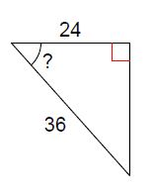
Solve:
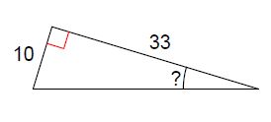
1.) 2.)

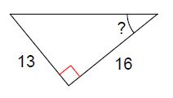
3.)

