**The Electromagnetic Wave Spectrum Notes 4/1/15**

**Warm- up:**



1. Convert 37.8 gigahertz to nanohertz. Put your answer in scientific notation.



2. A radio wave has a wavelength of 100 m. How many micrometers is this?



3. Convert 1.28 x 1012 microhertz to megahertz. Put your answer in standard notation.



**Electromagnetic Waves:**



Unlike _____________________________________ waves (from last unit) ______________________________



waves do not require a __________________________________ to ________________________________through.



**The speed of electromagnetic waves:**

All electromagnetic waves travel at __________________________________________ speed.



________________________________________________ miles per second



Or



_____________________________________________meters per second equal to _________________



This number is known as the ___________________________________________and is referred to using the letter ____



c = _________________________________________



So…. If________________________________, and c is the new speed, then our new formula is:



**c =**



**λ =**



**f =**



**The Electromagnetic Wave Spectrum**



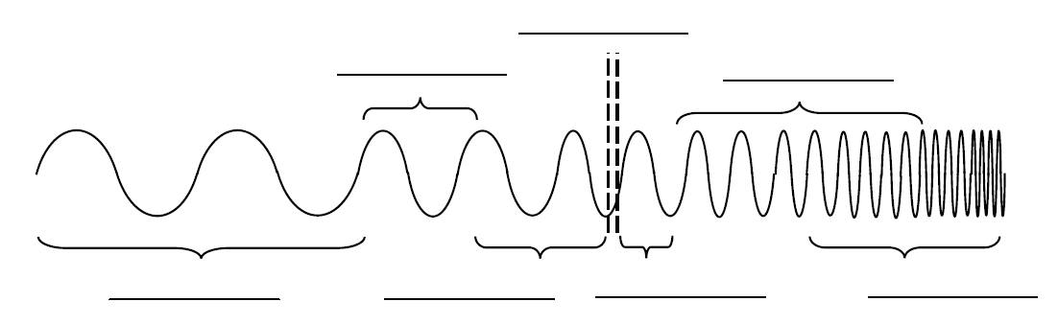



Higher frequencies are on the ____________________________of the spectrum



Longer wavelengths are on the ___________________________of the spectrum



High frequencies/ short wavelengths carry more _____________________________.



Where are the highest energies??



Example#1:



An electromagnetic wave has a wavelength of 2,000 nm. What is the frequency of this wave?



Formula:



Plug in numbers:



Answer:

