Scientific Notation and Conversion Review
Remember converting:
King Henry Died by drinking chocolate milk……..
King | Henry | Died | by | drinking | chocolate | milk
Kilo | Hecto | Deka | base | deci | centi | milli
Example:
Convert 1 km to millimeters:

K H D b d c m

Step 1: start with your given (1 km)
Step 2: find it on the chart (kilo)
Step 3: move the decimal place
however many times until you
get to what you are looking for (milli)

In this case, we started with 1 km. We moved the decimal to the right 6 times.
There are 1,000,000 millimeters in 1 km.

Do #1-3 Using K H D b d c m :
1. Convert 4 km to millimeters
2. Convert 18,000 centiliters to hectoliters
3. Convert 11 decimeters to dekameters

Scientific Notation:
Using powers of ten, we will simplify really large numbers or really small numbers.

For example:
300,000,000 is also equal to 3.0 x 10⁸

Step 1: Find the decimal point.
Step 2: Move the decimal point until
you get it to the right of the first whole number.
Step 3: Count how many times you moved
your decimal point—this is your power.

Example:
300,000,000

We moved the decimal point 8 times to the left.
This means 300,000,000 is equal to 3.0 x 10⁸
If we had the number .00000003 ---
This would be equal to 3.0 x 10⁻⁸
Why??

When we move the decimal to the left, the power is positive
When we move the decimal to the right, the power is negative

Extending KHDbdcm:
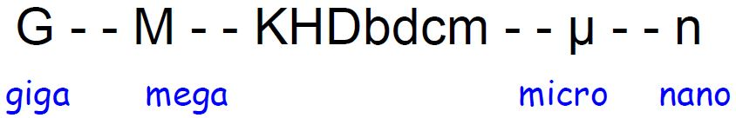
Do # 1-5 using Extended KHDbdcm ----- Put answers in standard notation and scientific notation!!!!!!!!
1. Convert 8 gigameters to meters

2. Convert 4.2 gigahertz to nanohertz.

3. Convert 84,600 micrograms to kilograms

4. Convert 0.405 Megahertz to microhertz

