The Doppler Effect Notes
https://www.youtube.com/watch?v=p-hBCcmCUPg
https://www.youtube.com/watch?v=h4OnBYrbCjY
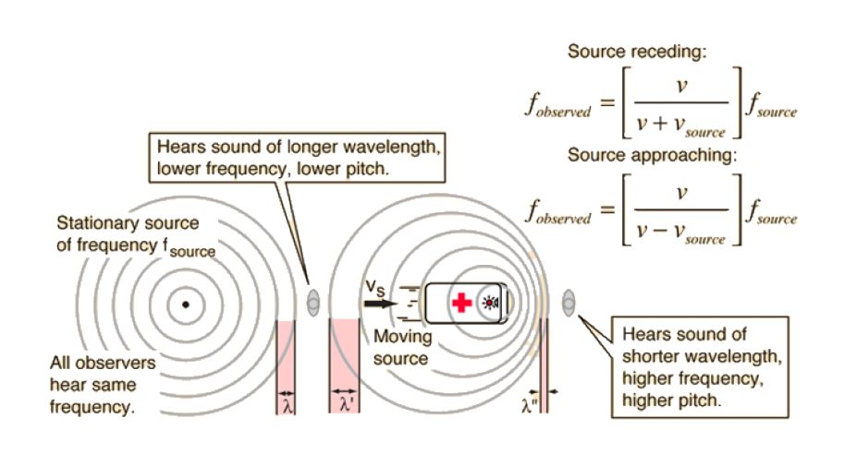
Formulas:
$$F_{observed= \left({v \atop v-vsource}\right)}f_{source}$$
USE WHEN OBJECT IS APPROACHING
Letters: | Meaning: | Measured in:
f_{observed}
v
V_{source}
F_{source}

$$F_{observed= \left({v \atop v+vsource}\right)}f_{source}$$
USE WHEN OBJECT IS RECEDING
Letters: | Meaning: | Measured in:
f_{observed}
v
V_{source}
F_{source}

Example 1:
The car in the video is honking its horn at a frequency of 9,000 Hz. If it's driving at 20 m/s what is the perceived frequency...
a) as the car approaches?
Formula:

Plug in numbers:

Solve:

Example 2: The car in the video is honking its horn at a frequency of 9,000 Hz. If it's driving at 20 m/s what is the perceived frequency...
b) as the car drives away?
Formula:

Plug in numbers:

Solve:

