**Waves Vocabulary**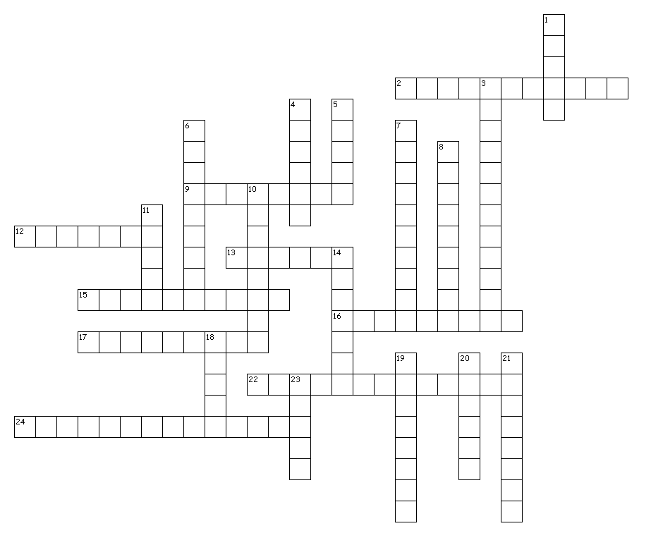



**Across**

2. The time the weight takes to move through one full back and forth swing in periodic motion is called ________.

9. Sound intensity as sensed by the ear and interpreted by the brain.

12. The number 9.8 meters per second squared is the number for Earth's ________.

13. number of seconds per one cycle

15. distance from crest to crest or trough to trough

16. Two variables A and B are _____ proportional if A increases as B decreases.

17. the number of cycles in one second (cycles per second)

22. The ____ ______ occurs when an observer hears a higher frequency and pitch as the object is approaching and a lower frequency and pitch as the object is receding.

24. The letter k in the Hooke’s law and potential energy formulas stands for ______ _______.

**Down**

1. Frequency is measured in _______.

3. a wave in which the vibrational displacement occurs in the same direction as the motion of the wave

4. ______ law states that the force exerted by a spring is directly proportional to the amount it is stretched

5. a rhythmic disturbance that carries energy through a medium

6. the maximum amount a disturbance is from a wave's rest position.

7. a wave in which the vibrational displacement occurs in a direction perpendicular to the motion of a wave

8. The moving parts of the standing waves

10. Two variables A and B are _____ proportional if A decreases as B decreases or A increases as B increases.

11. The wavelength of a wave is simply the length of one complete wave ____________.

14. the unit measurement for sound level.

18. The stationary points on a standing waves

19. The swinging of a pendulum back and forth is called _________ motion.

20. To find an object's _____, multiply by 9.8.

21. A _____ wave is a wave that is fixed on each end and travels through stationary points.

23. The highness or lowness of a sound wave