Unit 2 Study Guide: Constellations –
- 3 basic ways of locating something on Earth:
  - Geographic – City, State, Country
  - Local Coordinate System- 15 miles to the East
  - Global Coordinate System – Longitude and Latitude
- 3 basic ways of locating something in the Sky:
  - Geographic – Star or Constellation
  - Local Coordinate System – Altitude and Azimuth
  - Global Coordinate System – Right ascension and declination
- Horizon- where the land meets the sky
- Longitude – Angular distance north of the Equator
- Longitude- Angular distance East of Greenwich England (Prime Meridian)
- Celestial Sphere- imaginary sphere centered on Earth to which stars are affixed.
- Azimuth – angular distance from North – measured to the East
- Altitude- angular distance from the horizon
- Zenith – overhead point on celestial sphere
- 88 constellations in the sky
- We can see 45 constellations in GA

- An asterism is a layman’s term for constellation – “big dipper” is the asterism for ursa major.

- Spring - Vernal equinox – 0 hours, 0 degrees – March 21, 22
Summer – Summer solstice – 6 hours, 23.5ᵒ -- June 21, 22
Fall – Autumnal Equinox – 12 hours, 0ᵒ -- September 21,22
Winter – Winter Solstice – 18 hours, -23.5ᵒ -- December 21,22

- Right ascension- angular distance east of the vernal equinox (similar to longitude) measured in hours and minutes
- Declination- The angular distance north of the celestial equator (similar to latitude) measured in degrees
- Ecliptic—the path the sun takes in the sky. The earth is at a tilt – 23.5º
- 24 hour day— solar day—time it takes for the earth to complete one rotation of 361ᵒ
- 23 hours 56 mins – sidereal day – one rotation of the earth measured by position of the stars other than our sun. 360ᵒ the earth is rotating and revolving.
takes 4 minutes for objects in the sky to move 1ᵒ
- True or false…. If I go outside tonight at midnight and see Betelgeuse right above my head, I have to go outside tomorrow night at 12:04 and Betelgeuse is right above my head again.
FALSE---- Betelgeuse would be out at 11:56pm
- Organizing Stars:
  - Bayer System
  - 1. constellation (using the Latin possessive of the name)
  - 2. Greek letter (Alpha, Beta, Gamma, Delta, Epsilon, . . .)
  - Labeled in an approximate order of decreasing brightness for stars in the constellation.
    - Example Orion Constellation
    - Betelgeuse is also called Alpha-Orionis
    - Rigel is called Beta Orionis

- Rotation vs revolution:
  - Rotation- earth spinning on its axis (24 hours) rotates counter-clockwise
    - Daily motion of the sky is due to the earth’s rotation.
  - Revolution –
    - Tilt and revolution cause seasons
Circumpolar Constellations:
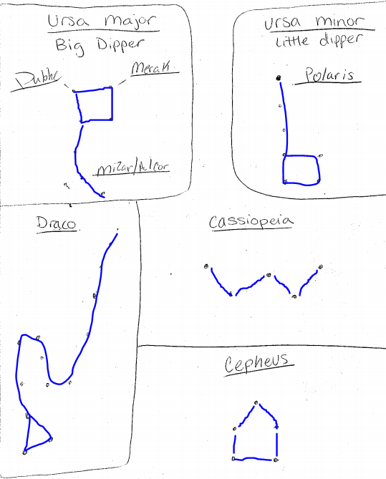

Winter Constellations:
