Saturn:
Saturn is the most oblate planet.
Named after Cronos – Saturn--- father of the main gods. Arm wrestled with Raya and had children. Eats his babies.
9.5 AUs away from the sun
7 rings
62 moons
53 are names
7 are spherical
know 3- Titan, Iopetus, Mimas
- Titan – largest moon of Saturn—bigger than mercury
  - Has thick atmosphere of nitrogen –yellow color (and methane)
  - Titan—draw a big yellow circle
- Iopetus
  - Draw: 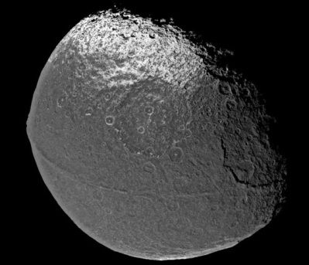
- Mimas is the moon—Herschel is the crater
  - Draw: 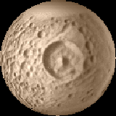
Atmosphere (matches Jupiter)
97% hydrogen
3% helium
Has Bands and Belts
** Density = 0.7 g/cm³ (could float in water)
Diameter = 9.4 times the diameter of the Earth
Saturn’s rings are named A, B, C, D, E, F, G
Cassini division
Rings are less than I mile thick and made of ice and rock
Shepherd satellites -- Moons in the rings—located in the F ring --– Pandora and Janice
- ROCHE Limit- when a moon, comet, asteroid comes in a too steep an angle or too fast and planet’s gravity rips it to pieces.
- Rings were formed by perhaps a comet or moon passing within the Roche Limit of Saturn.
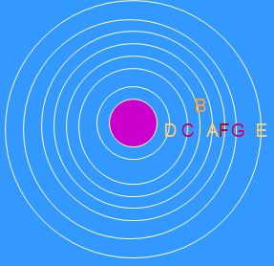
Drawing:
Cassini division is between the A and the B ring
Cassini probe is there now
Satellites are in the F ring

Probes: Voyager 1 and 2
Pioneer 11
Cassini - Huygens

Rotates: 10.2 hours
Revolves: 29.5 years
Axis tilt 25.3 degrees
Surface temp: 95 K
Atmospheric Pressure 1.4
Orbital inclination 2.5

