Electric Forces vs Gravitational Forces Fill in Notes 3/30/2020
5MinutePhysics Video
Electric and Gravitational Forces
- They are both field forces.
- Gravitational attraction: the Earth pulls on the Moon, and the Moon pulls on the Earth.
- Electric forces: Can be positive or negative.
- Gravitational force can only be positive.
- Electrical force is significantly stronger than gravitational force.
- Gravitational force is based on mass.
- Electrical force is based on charge.

Mikula’s video on Electric force and Gravitational Force formulas
Electric Force formula:
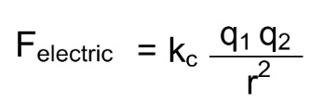
Fe = electrostatic force (N)
k_{c} = coulomb’s constant (9x10⁹ Nm²/C²)
q1 = charge of the first particle (C)
q2 = charge of second particle (C)
d = distance between 2 particles (m)
Gravitational Force formula:
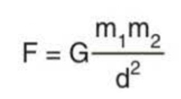
F = gravitational force (N)
G = gravitational constant (6.67x10⁻¹¹ Nm²/kg²)
m₁ = mass of object 1 (kg)
m₂ = mass of object 2 (kg)
d = distance between masses (m)

Coulomb’s Law Example:
A negative charge of -2.0 x 10⁻⁴ C and a positive charge of 8.0 x 10⁻⁴ C are separated by 0.30m. What is the force between the 2 charges?
(9.0 x 10⁹) (-2.0 x10⁻⁴) (8.0 x 10⁻⁴)
0.30²

F = -16,000 N or - 1.6 x 10⁴ N

Now you try one:
A negative charge of -6.0 x 10⁻⁶ interacts with a particle with a positive charge of 3.0 x 10⁻⁶. What is the force acting on the charges if they are 0.05 m away?

(9.0 x 10⁹) (-6 x10⁻⁶) (3.0 x 10⁻⁶)
0.05²

-64.8 N

