Circuit Notes
What is a Circuit?
What is a circuit? A route through which an electrical current can flow.
What is a closed circuit? A complete, unbroken path in which electrons can flow.
What is a short circuit? When there is a break in the circuit and electrons take a path short of the complete circuit. Electricity will follow the path of least resistance.

Types of Electrical Circuits:
What is a series circuit? When lights (resistors) are lined up one after another on a circuit. When one light goes out, all lights go out because there is only one path for electrons to flow.
What is a parallel circuit? The wires and light bulbs (resistors) run parallel to each other rather than having all the bulbs in a row. This creates multiple pathways for the electrons to flow. If one light bulb goes out, the others will stay on since the electrons can continue to flow.

Solving for a Series circuit:
Rules when solving for Series circuits:
Resistance: Add up all of the resistors. R_{T} = R₁ + R₂ + R₃…
Current: Current stays the same at each resistor I_{T} = I₁ = I₂ = I₃…
Voltage: Add up to get total voltage ΔV_{T} =ΔV₁+ ΔV₂ + ΔV₃…
Ohm’s Law is V=IR
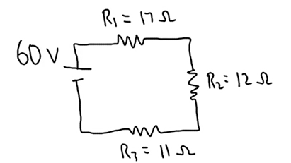
Be able to fill in chart and solve for each missing piece of the circuit:
Given information in diagram is in Green
Solved information is diagram is in Blue
R_{T}= 40 Ω | I_{T}= 1.5 A | V_{T}= 60 V
R₁= 17 Ω | I₁= 1.5 A | V₁= 25.5 V
R₂= 12 Ω | I₂= 1.5 A | V₂= 18 V
R₃= 11 Ω | I₃= 1.5 A | V₃=16.5 V

To solve for RT, add 17 Ω +12 Ω +11 Ω = 40 Ω
To solve for total current:
V=IR
60V = I (40 Ω)
I = 1.5A
In a series circuit, current is the same at each location.

To solve for Voltage drop at each resistor:
To solve for voltage drop at resistor 1:
V₁ = I₁R₁
V₁ = (1.5A)(17 Ω)
V₁ = 25.25 V
To solve for voltage drop at resistor 2:
V₂ = I₂R₂
V₂ = (1.5A)(12 Ω)
V₂ = 18 V
To solve for voltage drop at resistor 3:
V₃ = I₃R₃
V₃ = (1.5A)(12 Ω)
V₃ = 16.5 V

