Circuit Notes
What is a Circuit?
What is a circuit? _______________________________________________________________
What is a closed circuit? _________________________________________________________
What is a short circuit? __________________________________________________________

Types of Electrical Circuits:
What is a series circuit? __________________________________________________________
What is a parallel circuit? _________________________________________________________

Solving for a Series circuit:
Rules when solving for Series circuits:
Resistance: Add up all of the resistors. R_{T} = R₁ + R₂ + R₃…
Current: Current stays the same at each resistor I_{T} = I₁ = I₂ = I₃…
Voltage: Add up to get total voltage ΔV_{T} =ΔV₁+ ΔV₂ + ΔV₃…
Ohm’s Law is V=IR
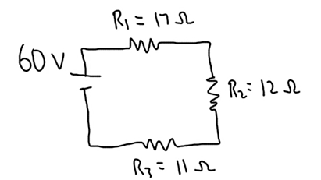
Be able to fill in chart and solve for each missing piece of the circuit:
Given information in diagram is in GREEN
R_{T}= | I_{T}= | V_{T}= 60 V
R₁= 17 Ω | I₁= | V₁=
R₂= 12 Ω | I₂= | V₂=
R₃= 11 Ω | I₃= | V₃=

To solve for RT, add 17 Ω +12 Ω +11 Ω = ______
To solve for total current:
V=IR
60V = I (40 Ω)
I = ______
In a series circuit, current is the same at each location.

To solve for Voltage drop at each resistor:
To solve for voltage drop at resistor 1:
V₁ = I₁R₁
V₁ = (1.5A)(17 Ω)
V₁ = ______
To solve for voltage drop at resistor 2:
V₂ = I₂R₂
V₂ = (1.5A)(12 Ω)
V₂ = ______
To solve for voltage drop at resistor 3:
V₃ = I₃R₃
V₃ = (1.5A)(12 Ω)
V₃ = ______

