Bending Light PhET Lab Name:
Go to https://phet.colorado.edu/en/simulation/bending-light and open the Bending Light Sim. Click on Intro.
Move the protractor and line it up with the surface of the interface between the two materials.
Press the red button to turn on the laser.
For each scenario, select the top and bottom material as specified in each data table. Record the index of refraction, n, for each material in the data table. Choose two incident angles between 5º – 85º for each scenario, and record the incident, reflected, and refracted angles in the table.
After filing in the table, draw the rays as they are in the sim (you only need to draw one incident angle, not both).
Top Material: Air Top Index of Refraction (n):
Bottom Material: Water Bottom Index of Refraction (n):
Incident Angle | Reflected Angle | Refracted Angle

Top Material: Air Top Index of Refraction (n):
Bottom Material: Glass Bottom Index of Refraction (n):
Incident Angle | Reflected Angle | Refracted Angle

Top Material: Water Top Index of Refraction (n):
Bottom Material: Glass Bottom Index of Refraction (n):
Incident Angle | Reflected Angle | Refracted Angle

Top Material: Water Top Index of Refraction (n):
Bottom Material: Air Bottom Index of Refraction (n):
Incident Angle | Reflected Angle | Refracted Angle

Top Material: Glass Top Index of Refraction (n):
Bottom Material: Air Bottom Index of Refraction (n):
Incident Angle | Reflected Angle | Refracted Angle

Top Material: Glass Top Index of Refraction (n):
Bottom Material: Water Bottom Index of Refraction (n):
Incident Angle | Reflected Angle | Refracted Angle

- Based on your data in the data tables, what patterns do you observe? Write at least three summary statements.

- Now you will solve for a mystery material.
Top Material: Air Top Index of Refraction (n):
Bottom Material: Mystery A Bottom Index of Refraction (n):? (Solve for this)
Incident Angle | Refracted Angle

Using Snell’s Law formula, solve for the Index of refraction of Mystery A. Using the chart below, determine what the material of Mystery A is.
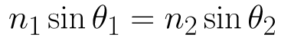
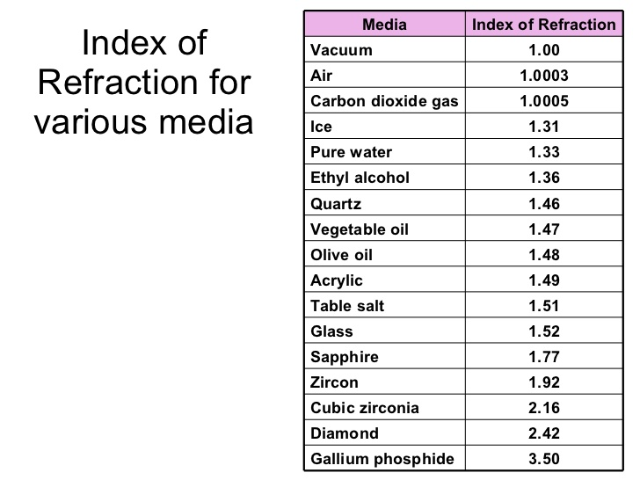

Mystery A is _________________________.

- Now solve for Mystery Material B.
Top Material: Air Top Index of Refraction (n):
Bottom Material: Mystery B Bottom Index of Refraction (n):? (Solve for this)
Incident Angle | Refracted Angle

Mystery B is __________________________.

