Acceleration Notes Continued 8/23/17
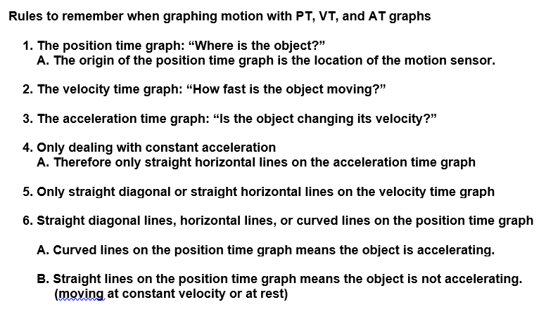

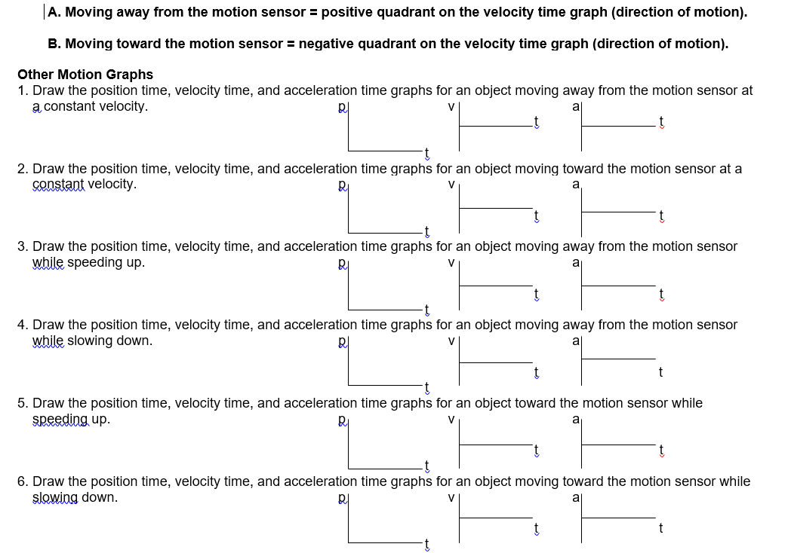

Acceleration Practice Problems
- A ball rolls for 15 seconds. If the initial velocity of the ball was 0.8 m/s and the
final velocity was 7 m/s, what was the acceleration of the ball ?
Formula: | Plug in numbers: | Answer:

- A meteoroid changed velocity from 1.0 km/s to 1.8 km/s in 0.03 seconds. What is the acceleration of
the meteoroid?
Formula: | Plug in numbers: | Answer:

- A car going 50mph accelerates to pass a truck. Five seconds later the car is going 80mph. Calculate
the acceleration of the car.
Formula: | Plug in numbers: | Answer:

- The space shuttle releases a space telescope into orbit around the earth. The telescope goes from
being stationary to traveling at a speed of 1700 m/s in 25 seconds. What is the acceleration of the
satellite?
Formula: | Plug in numbers: | Answer:

- A ball is rolled at a velocity of 12 m/sec. After 36 seconds, it comes to a stop. What is the
acceleration of the ball?
Formula: | Plug in numbers: | Answer:

