Hooke’s Law Notes

The Mass on a Spring
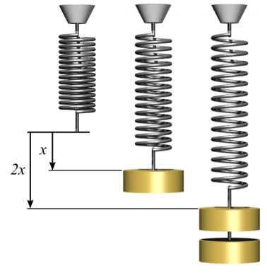
The first spring ____________________________________stretch because nothing is attached to it.
The second spring is ___________________________________since there is __________________________
acting on the spring. The spring is stretched a ______________________________ of _______.
The third spring is stretched even _______________________________ when more__________________ was added.
Let’s look at Hooke’s Law---
Hooke’s law states that the ___________________exerted by a spring is directly _______________________ to the amount that the spring is ________________________________.
The force exerted on a spring is equal to the ________________________________________________ times the __________________________________ the spring is compressed or stretched.

F stands for _______________________ and is measured in _________________
k stands for ________________________________and is measured in ________
x stands for ________________________ and is measured in ________________

Potential Energy in a Spring
The _______________________________________ in a spring is equal to one-half times the product of the ___________________________________________ and the square of the ____________________________
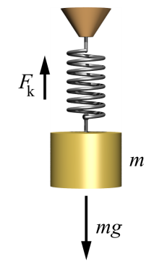

PE_{spring} stands for _____________________________________ of the spring and is measured in ___________
k stands for __________________________________________ and is measured in ____________________
x stands for __________________________________________ and is measured in ____________________

Examples:
1. You are weighing bananas at the grocery store on a spring scale. What is the force exerted on the banana if the spring is stretched a length of 0.5 m and the spring constant is 120 N/m?
Formula:
Plug in numbers:

Solve:

2. If a spring has a constant of 4 N/m and is stretched .5 m, what is the force of the spring?
Formula:
Plug in numbers:

Solve:

3. A spring is stretched .6m when a mass of 4kg is hung on it. Calculate the spring constant of this spring.
Formula:
Plug in numbers:

Solve:

4. A spring is stretched 0.4m from equilibrium. The spring constant of the spring is 2000 N/m. What is the potential energy of the spring?
Formula:
Plug in numbers:
Solve:

5. A compressed spring has 15,000 J of stored energy. If the spring constant is 1,000 N/m, how far is the spring compressed?
Formula:
Plug in numbers:

Solve:

