Friction
Friction is a force whose direction goes against an applied force.
2 kinds of friction:
Static Friction: Frictional force that is exerted when an object is stationary (not moving).
F_{f,s} ˂ μF_{n}
Static frictional force is less than or equal to the coefficient of friction X normal force
μ: greek letter mu, coefficient of friction. Unitless number that indicates how rough or smooth a surface is.
High μ: rough (sand paper)
Low μ: smooth (ice)

Kinetic Friction: A frictional force that is exerted against an applied force when an object is moving.
(Sliding friction)
F_{f} = μ F_{N}
Friction = coefficient of friction X normal force

Example of Kinetic Friction
A 950kg car has run out of gas and is being pushed with a force of 3,000N. If the coefficient of friction of the road is 0.3, (a) draw a free body diagram and (b) find the acceleration of the car.
F_{N} = 9,310N
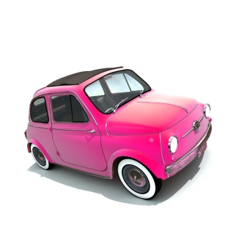
Find the car’s weight:
F_{W} = mg
F_{w} = (950kg)(9.8m/s²)
F_{w} = 9310 N
F_{A} = 3,000N
F_{f} = 2793N
Because the car is not on an
incline, the F_{w} = F_{N}
Find the Frictional Force:
F_{W} = 9,310N
Find the car’s acceleration:
a = F/m
a = 207N / 950kg
a = 0.218 m/s²
F_{f} = μ F_{N}
F_{f} = 0.3 (9310N)
F_{f} = 2793N

