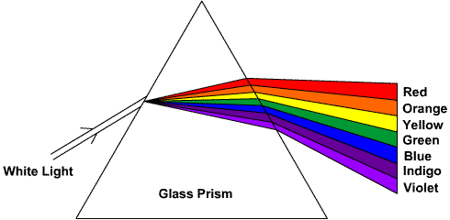
Visible Light notes

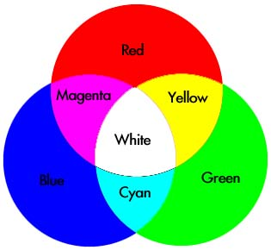
___________________________ light is a combination of _______________________________ in the visible light spectrum.

Primary colors: __________________________, _________________________, ________________________

Secondary Colors: _________________________, ________________________, ________________________

Combining all three primary colors will give you _______________________

Complementary Colors:
Two colors are __________________________________ if they form ___________________ light when ________________________________

Examples:
________________________________ and _____________________________ are complimentary.

________________________________ and _____________________________ are complimentary.
Examples of Reflection:
A piece of white paper under green light would appear to be _______________________________.

Mrs. Mikula’s cyan colored shirt reflects __________________________________________________
and absorbs _________________.

A piece of paper absorbs magenta, the paper is colored ____________________.

A car absorbs red, green, and blue, so the car appears ______________.

Whatever color is ____________________________ is what you __________________.
Whatever color is ____________________________ is the _______________________________ color.

