The Electromagnetic Wave Spectrum Notes
Warm- up:
1. Convert 37.8 gigahertz to nanohertz. Put your answer in scientific notation.

2. A radio wave has a wavelength of 100 m. How many micrometers is this?

3. Convert 1.28 x 10¹² microhertz to megahertz. Put your answer in standard notation.

Electromagnetic Waves:
Unlike _____________________________________ waves (from last unit) ______________________________
waves do not require a __________________________________ to ________________________________through.
The speed of electromagnetic waves:
All electromagnetic waves travel at __________________________________________ speed.
________________________________________________ miles per second
Or
_____________________________________________meters per second equal to _________________
This number is known as the ___________________________________________and is referred to using the letter ____
c = _________________________________________
So…. If________________________________, and c is the new speed, then our new formula is:

c =
λ =
f =
The Electromagnetic Wave Spectrum

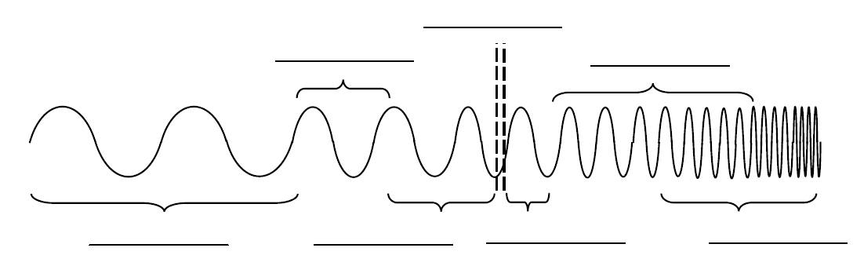

Higher frequencies are on the ____________________________of the spectrum
Longer wavelengths are on the ___________________________of the spectrum
High frequencies/ short wavelengths carry more _____________________________.
Where are the highest energies??

Example#1:
An electromagnetic wave has a wavelength of 2,000 nm. What is the frequency of this wave?
Formula:

Plug in numbers:

Answer:

