Mechanical Energy Assignment
PE_{G} = mgh KE = ½mv²

- A car is lifted a certain distance in a service station and therefore has potential energy relative to the floor. If it were lifted twice as high, how much potential energy would it have?

- Two cars are lifted to the same elevation in a service station. If one car is twice as massive as the other, how do their potential energies compare?

- How many joules of potential energy does a 0.5 kg book gain when it is elevated 4 m? When it is elevated 8 m?

- A moving car has kinetic energy. If it speeds up until it is going four times as fast, how much kinetic energy does it have in comparison?

- Consider a ball thrown straight up in the air. At what position is its kinetic energy a maximum? Where is its gravitational potential energy a maximum?

- At what point in its motion is the KE of a pendulum bob a maximum? At what point is its PE a maximum? When its KE is half its maximum value, how much PE does it have?

- What is the kinetic energy of a 2 kg snow ball thrown through the air at 5 m/s?

- A 5kg book is sitting on top of a counter. The book has 55 J of potential energy. How tall is the counter?

- The 5kg book slides off the counter and has 55 J of kinetic energy just before it lands on the ground. How fast is the book falling just before it hits the ground?

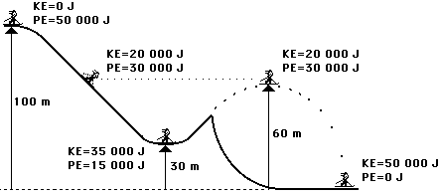
10. Solve for the missing parts:

Elastic Potential Energy
PE_{e} = ½ k x²
11. A spring is stretched 6 cm and has a spring constant of 600 N/m. Calculate the potential energy of the spring.

12. If you use the spring from problem #11 and stretch it a distance of 10cm, what is the potential energy?

13. A spring with a spring constant of 400 N/m has a mass hung on it so that it stretches 8 cm. Calculate the potential energy in the spring.

14. A spring has a spring constant of 256 N/m. How far must it be stretched to give it an elastic potential energy of 48 J?

