Mirror and Lens Online Lab Name:______________________________
Go to https://simbucket.com/lensesandmirrors/
1- Click on the arrow and the button to make it say MIRROR:
2- Click Ray 1 ON and Ray 2 ON:
3-Move the object by dragging the arrow to the desired location. Fill in the chart accordingly:
CONCAVE MIRROR
Focal Length | Object Distance | Object Height | Image Distance | Image Height | Describe the Image:  Circle all that apply
20 cm | 70 cm | 15.5 cm |  |  | Real or Virtual or Neither  Inverted or Upright or Neither  Enlarged or Smaller or Same Size or Neither
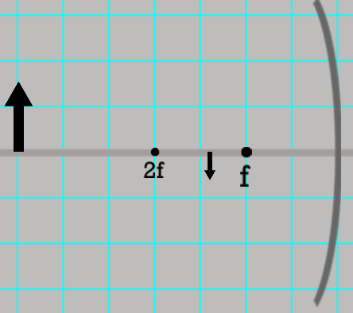
Draw the ray diagram:

Focal Length | Object Distance | Object Height | Image Distance | Image Height | Describe the Image:  Circle all that apply
20 cm | 40 cm | 15.5 cm |  |  | Real or Virtual or Neither  Inverted or Upright or Neither  Enlarged or Smaller or Same Size or Neither
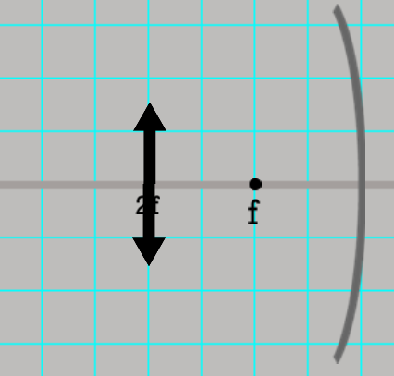
Draw the ray diagram:

Focal Length | Object Distance | Object Height | Image Distance | Image Height | Describe the Image:  Circle all that apply
20 cm | 30 cm | 15.5 cm |  |  | Real or Virtual or Neither  Inverted or Upright or Neither  Enlarged or Smaller or Same Size or Neither
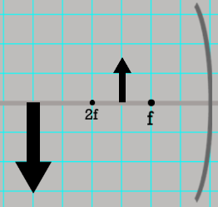
Draw the ray diagram:

Focal Length | Object Distance | Object Height | Image Distance | Image Height | Describe the Image:  Circle all that apply
20 cm | 20 cm | 15.5 cm |  |  | Real or Virtual or Neither  Inverted or Upright or Neither  Enlarged or Smaller or Same Size or Neither
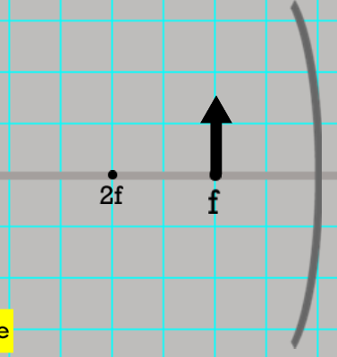
Draw the ray diagram:

Focal Length | Object Distance | Object Height | Image Distance | Image Height | Describe the Image:  Circle all that apply
20 cm | 6 cm | 15.5 cm |  |  | Real or Virtual or Neither  Inverted or Upright or Neither  Enlarged or Smaller or Same Size or Neither
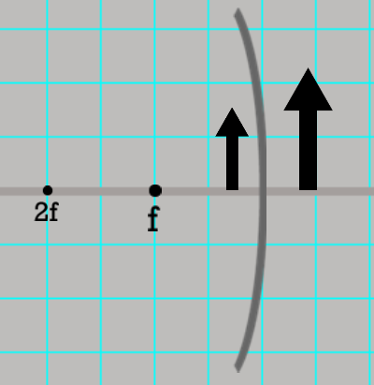
Draw the ray diagram:

CONVEX MIRROR
Drag the arrow to the right side of the mirror – this becomes a convex mirror.
Focal Length | Object Distance | Object Height | Image Distance | Image Height | Describe the Image:  Circle all that apply
20 cm | 20 cm | 15.5 cm |  |  | Real or Virtual or Neither  Inverted or Upright or Neither  Enlarged or Smaller or Same Size or Neither
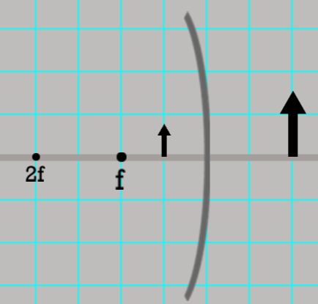
Draw the ray diagram:

Focal Length | Object Distance | Object Height | Image Distance | Image Height | Describe the Image:  Circle all that apply
20 cm | 40 cm | 15.5 cm |  |  | Real or Virtual or Neither  Inverted or Upright or Neither  Enlarged or Smaller or Same Size or Neither
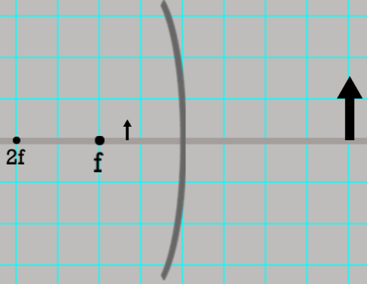
Draw the ray diagram:

CONVERGING LENS
1- Click on the arrow and the button to make it say LENS and CONVERGING:
2- Click Ray 1 ON and Ray 2 ON:

3-Move the object by dragging the arrow to the desired location. Fill in the chart accordingly:

Focal Length | Object Distance | Object Height | Image Distance | Image Height | Describe the Image:  Circle all that apply
20 cm | 60 cm | 15.5 cm |  |  | Real or Virtual or Neither  Inverted or Upright or Neither  Enlarged or Smaller or Same Size or Neither
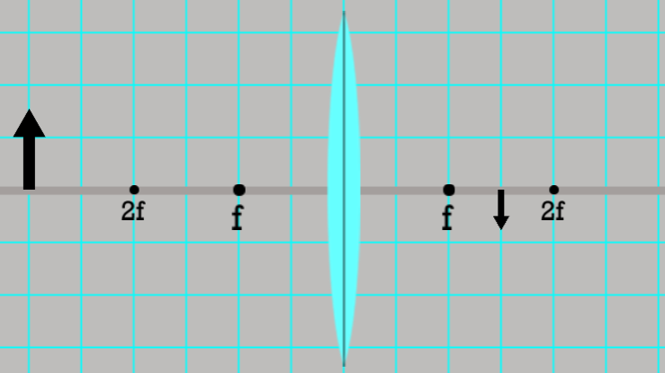
Draw the ray diagram:

Focal Length | Object Distance | Object Height | Image Distance | Image Height | Describe the Image:  Circle all that apply
20 cm | 40 cm | 15.5 cm |  |  | Real or Virtual or Neither  Inverted or Upright or Neither  Enlarged or Smaller or Same Size or Neither
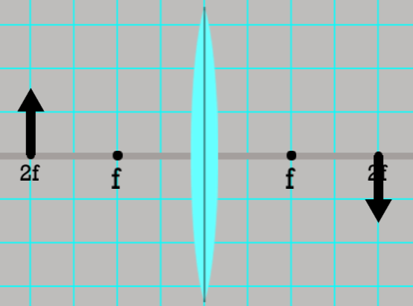
Draw the ray diagram:

Focal Length | Object Distance | Object Height | Image Distance | Image Height | Describe the Image:  Circle all that apply
20 cm | 30 cm | 15.5 cm |  |  | Real or Virtual or Neither  Inverted or Upright or Neither  Enlarged or Smaller or Same Size or Neither
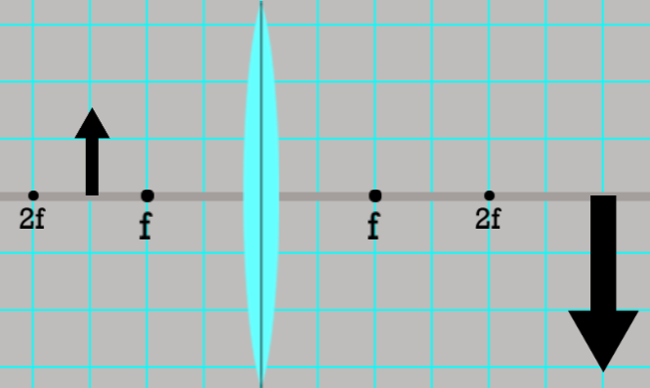
Draw the ray diagram:

Focal Length | Object Distance | Object Height | Image Distance | Image Height | Describe the Image:  Circle all that apply
20 cm | 20 cm | 15.5 cm |  |  | Real or Virtual or Neither  Inverted or Upright or Neither  Enlarged or Smaller or Same Size or Neither
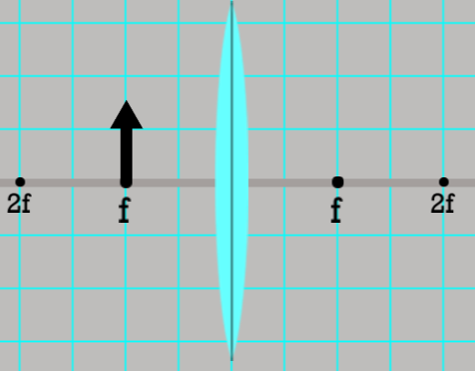
Draw the ray diagram:

Focal Length | Object Distance | Object Height | Image Distance | Image Height | Describe the Image:  Circle all that apply
20 cm | 10 cm | 15.5 cm |  |  | Real or Virtual or Neither  Inverted or Upright or Neither  Enlarged or Smaller or Same Size or Neither
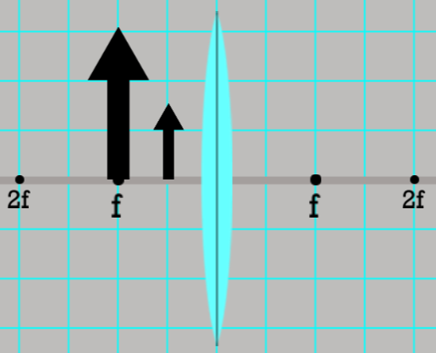
Draw the ray diagram:

DIVERGING LENS
1- Click on the arrow and the button to make it say LENS and DIVERGING:
2- Click Ray 1 ON and Ray 2 ON:

3-Move the object by dragging the arrow to the desired location. Fill in the chart accordingly:

Focal Length | Object Distance | Object Height | Image Distance | Image Height | Describe the Image:  Circle all that apply
20 cm | 30 cm | 15.5 cm |  |  | Real or Virtual or Neither  Inverted or Upright or Neither  Enlarged or Smaller or Same Size or Neither
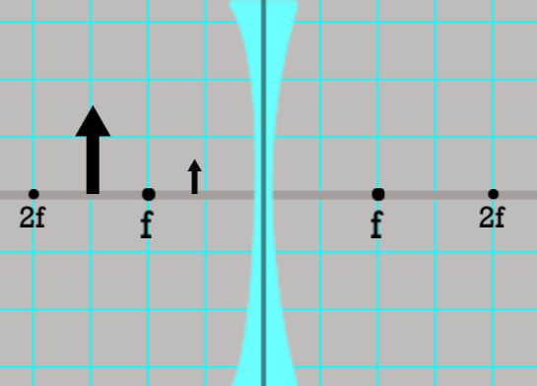
Draw the ray diagram:

Focal Length | Object Distance | Object Height | Image Distance | Image Height | Describe the Image:  Circle all that apply
20 cm | 20 cm | 15.5 cm |  |  | Real or Virtual or Neither  Inverted or Upright or Neither  Enlarged or Smaller or Same Size or Neither
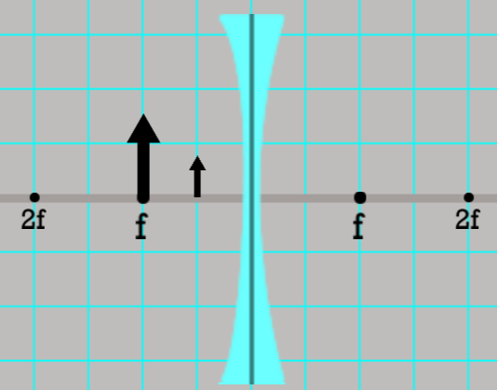
Draw the ray diagram:

Questions:
1. What type of mirror produces ONLY smaller, upright, virtual images?

2. Where would you find a CONVEX MIRROR?

3. What type of lens produces ONLY smaller, upright, virtual images?

4. What is an example of a CONCAVE MIRROR?

